ML CLASSIFIER PROJECT – SENTIMENT ANALYSIS OF RIEVIEWS FOR THE “myWorldLink” APPLICATION

- Introduction:
This project establishes a robust, end-to-end Machine Learning pipeline which is designed to continuously monitor and analyze customer feedback (app reviews) for the “myWorldLink” application.
Our system is engineered in distinct, reliable stages, like Ingestion & Cleaning where we fetch raw reviews from the Google Play Store, immediately filter out non-English reviews (specifically Nepali/Devanagari text) to maintain data quality, and apply essential NLP cleaning (removing emojis, stop words).
Labeling & Feature Engineering, where review star ratings are converted into a clear sentiment label (Positive or Negative). Concurrently, a rule-based extractor identifies and separates specific customer suggestions (e.g., “please fix”, “need to improve”) from general complaints.
Modeling the cleaned, labeled text is used to train a Logistic Regression classifier. This model is saved and reused to instantly predict the sentiment and confidence for any new incoming review.

- Objectives:
The primary objective of this project is to build a sentiment analysis using Machine Learning to monitor and analyze customer sentiment from app reviews. The system provides two main deliveries:
- Sentiment Classification: Categorizing reviews as POSITIVE or NEGATIVE with confidence score.
- Suggestion Extraction: Identifying and extracting actionable feature requests or bug reports.

- Tools and Technologies Used:

Category | Tool/Library | Purpose/Description
Programming Language | Python 3.13 | Crore programming language used for the entire project
Data processing | Pandas, NumPy | Data manipulation and cleaning
Natural Language Processing (NLP) | nltk, emoji, re(regex) | Tokenization, stopword removal and emoji handling
Machine Learning | Hugging face transformers | Pre-trained transformer model for sentiment classification
Database and database  Handling | SQLite3, pandas | Local database for persistent review and suggestion storage, data manipulation, transformation, and persistent storage.
Concurrency | ThreadPoolExecuter | Enhances performance by parallelizing review processing
Development Environment | Visual Studio Code | Main IDE used for writing, debugging, and testing
Version Control | Git & GitHub | Source code tracking and collaborative development
Data Ingestion | Google_play_scraper | Fetching live app reviews
Vectorization | TfidfVectorizer | Converting text into numerical features for the model.

- System Architecture:
The system follows a modular, layered and architecture separating preprocessing, analysis, and storage.
Each component communicates through CSV files or the SQLite database, ensuring data portability.
Architecture Diagram:
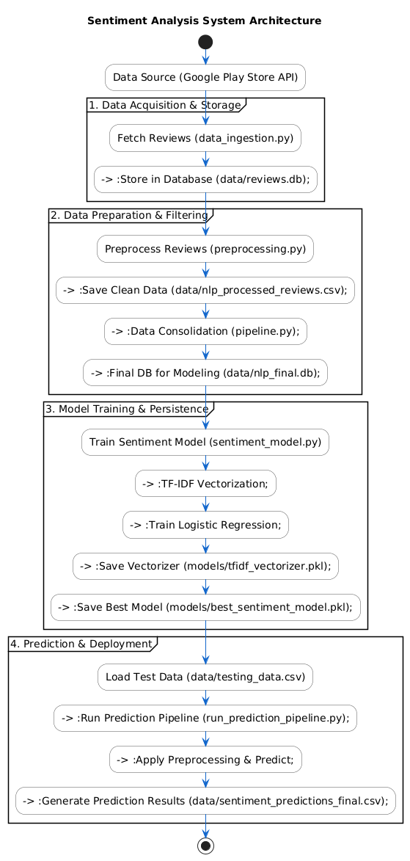
- Development Flow (Continuous Refinement):

The project followed an iterative and modular development approach:

- Modularity: Each major step (Ingestion, preprocessing, modeling) was isolated into its own Python file (py), ensuring code is reusable and easy to debug.
- Robustness & Persistence: Database integration (database_utils.py) was prioritized to ensure data integrity. Raw data is saved immediately upon fetching, and finally clean data is saved before modeling, making the pipeline fully restart able at any stage.
- Refactoring for Deployment: Critical fixes were applied to the final prediction script (run_prediction_pipeline.py) to address Unicode errors and, most importantly, robustly identify the correct review column in the test data, ensuring the model predicts on actual text, not on extraneous IDs.

- Technical Implementation: Component Breakdown

The pipeline is organized into seven core scripts, executed sequentially to move data from raw text to final prediction.

- Data Ingestion (data_ingestion.py, database_utils.py)
- Input: Google play Store API (via Google_play_scraper).
- Process:
- Data_ingestion.py: fetches reviews for a specified app_id and saves them using database_utils.py.
- Database_utils.py: creates and manages a SOLite database(data/reviews.db) to store the raw reviews, ensuring a permanent, untouched record of the source data.

- Output: data/reviews.db (Raw data table).

- Preprocessing & Feature Engineering (preprocessing.py, suggestion_extractor.py)
- Input: Raw reviews from data/reviews.db.
- Process:
- text cleaning: Text is lowercased, and emojis, punctuation, and English stopwords are removed.
- Non-English Filtering: A dedicated check(is_nepali) is used to filter out reviews containing Devanagari script, ensuring the model is trained only on the target language (English).
- Labeling: Review Scores(ratings) are mapped to POSITIVE or NEGATIVE labels to create the target variable for training.
- Suggestion Extraction: It uses rule-based matching (regex keywords like ‘fix’, improve’, ‘should’) to flag and extract feature suggestions.
- Output: The final, clean, and labeled data stored in data/nlp_processed_reviews.csv.

- Data Consolidation (pipeline.py)
- Input: data/nlp_processe_reviews.csv.
- Process: This script is a final data validation and persistence step. It loads the processed csv, filters out only the required cleaned_text and sentiment columns, and saves this essential set into the final modeling database, data/nlp_final.db.
- Output: data/nlp_final.db (Clean, modeling-ready table).

- Data Consolidation (pipeline.py)
- Input: data/nlp_processed_reviews.csv.
- Process: This script is a final data validation and persistence step. It loads the processed CSV, filters out only the required cleaned_text and sentiment columns, and saves this essential set into the final modeling database, data/nlp_final.db.
- Output: data/nlp_final.db (Clean, modeling-ready table).

5. Prediction/Deployment (run_prediction_pipeline.py)
- Input: Unseen or test data (data/testing_data.csv).
- Process: This script acts as the final deployment interface.
- Asset Loading: Loads the saved model.pkl and vectorizer.pkl.
- Preprocessing Consistency: Applies the exact same cleaning functions from preprocessing_for_prediction.py to the new data, ensuring consistency between training and prediction environments.
- Prediction: Generates sentiment label (POSITIVE/NEGATIVE) and a confidence score.
- Evaluation: Calculates prediction Accuracy against the actual labels in the test data.
- Output: data/sentiment_predictions_final.csv (Final report).

